Watermelon Grafting Methods
Research Report 2007

Dr. Richard Hassell
Mr. Frederic D. Memmott

Tongue approach grafting
The approach graft also referred to as the tongue approach, is relatively simple and is the oldest grafting style. This method is preferred by inexperienced growers because of its high success rate, and low care requirement. This method does not require a healing chamber. The watermelon seed should be planted five days before the rootstock seed. When at least one true leaf is present, a cut is made, using a sharp blade, in both the stem of the watermelon and rootstock; one up and the other down respectively. Each cut should be comparable in length so they can match up together. Each slit is like a tongue, and are fitted together and sealed with an aluminum wrap to allow healing to take place. Healing begins within three days and the rootstock stem is removed. Seven days after grafting the watermelon root is cut and the aluminum wrap can be removed allowing the new graft to depend solely on the new rootstock. The advantages of using this graft is that it has a high survival rate, it’s simple, does not require low light and a high humidity environment for healing to take place, however there is substantial labor in returning throughout the healing process to cut the watermelon root, and remove the rootstock top. Twice as much greenhouse spaces are needed for this type of graft.
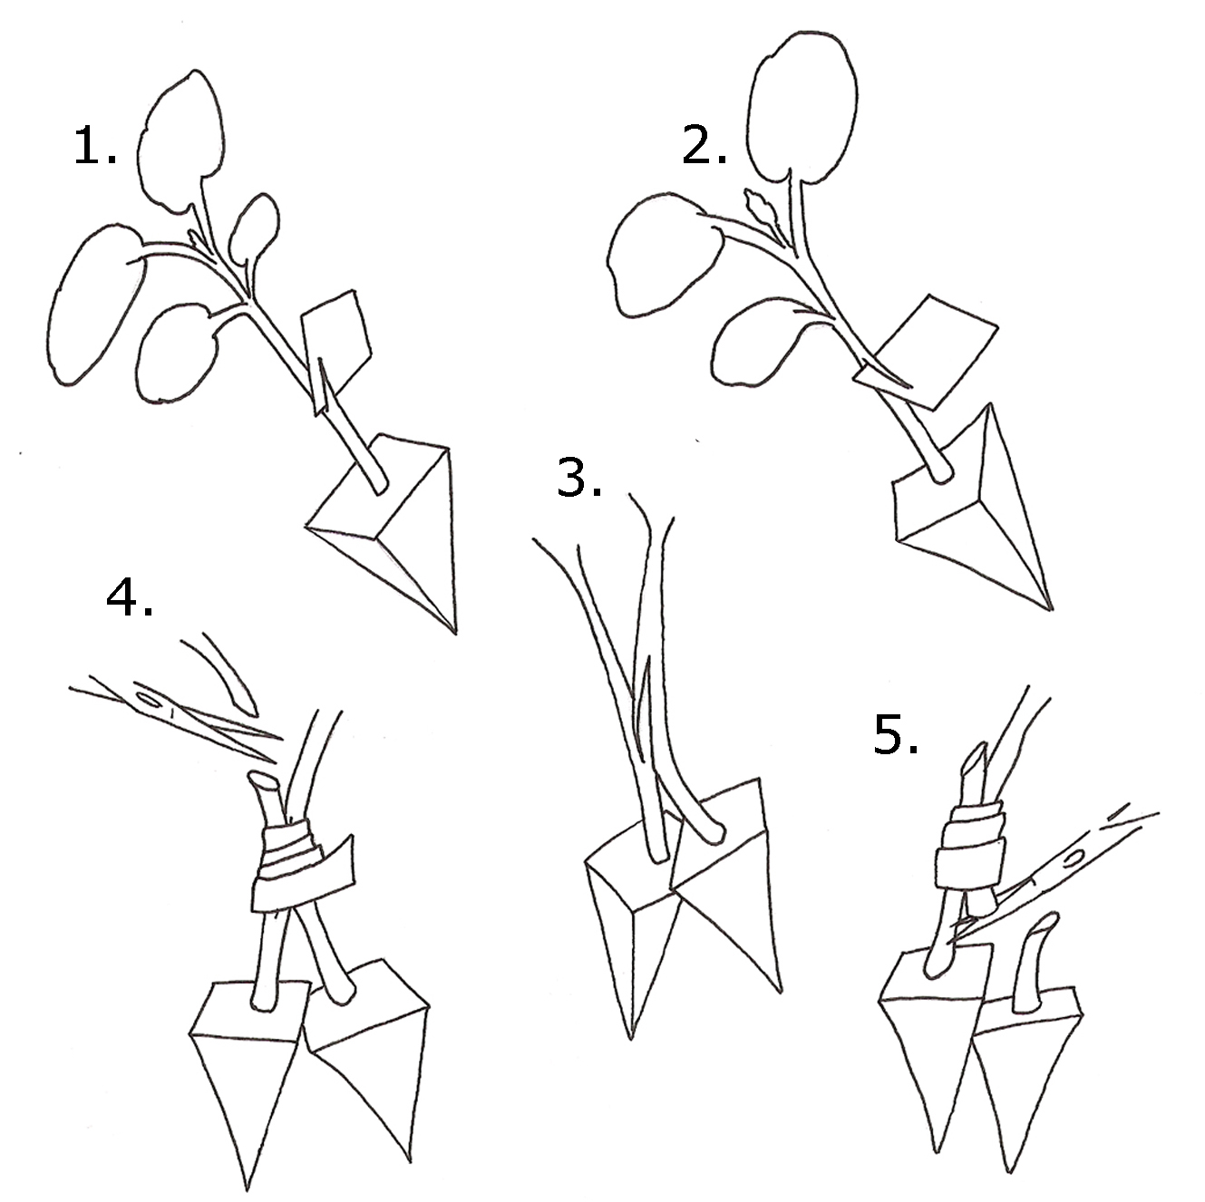

One cotyledon Graft
The splice graft also known as: one cotyledon graft, and slant graft, is moderately simple and is perhaps the most popular among experienced growers and commercial nurseries. This graft is performed by hand, machine and robot. Plants are ready to graft when there is at least one true leaf on both the scion and the rootstock. The rootstock is carefully cut using a sharp blade at a diagonal to remove one cotyledon and the complete meristem. The angle should be close 45º degrees to have good surface area. The scion is cut at an opposite 45º angle approximately one inch below its cotyledons to facilitate clamping. The watermelon and rootstock are then joined together with a spring clam that is placed around the outside region of the splice. Following the grafting, the plants require shade, high humidity and temperatures around 77º F for three days. This method is less labor intensive requiring just a few tools, the removal of the clamp, and an increase of light and decrease of humidity after the third day to gradually begin normalizing them to the environment. Another advantage is that this graft produces strong. Disadvantages are few and include a need for a good acclimating facility because poor environmental controls in humidity, light and temperature may cause high losses. If the graft is done properly and on time the root stock may develop new shoots of it own and cause the watermelon to be aborted.
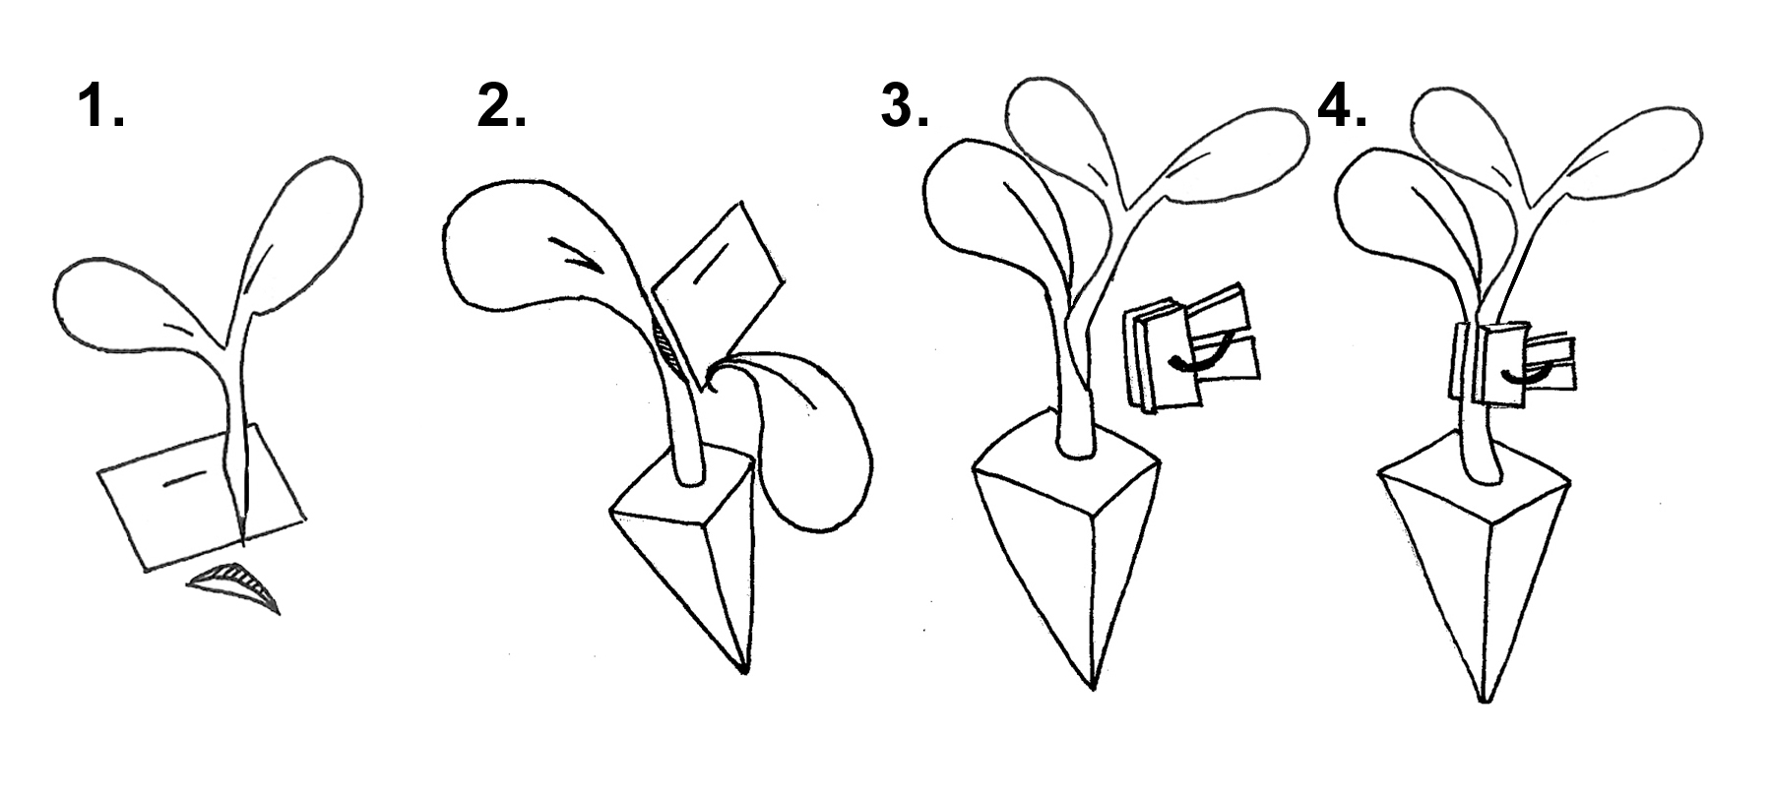

Hole insertion grafting
The hole insertion graft is favored by some watermelon growers because of the smaller watermelon size compared to the rootstock. Watermelon seeds are sown a few days after the rootstock; days vary depending on the rootstock. Grafting begin 7-8 days after the watermelon seeds are sown, and requires at least one leaf on the watermelon and one small leaf on the rootstock. This being said, some growers insert very young watermelon seedlings. A specialized tool, such as a bamboo stick or small drill bit, is used to remove all of the meristem from the rootstock leaving a small hole with a small splice along both sides. The watermelon is then cut at a slant and placed within the hole. The grafted is then secured with a clamp and placed into a healing chamber with temperatures at 77º F, high humidity, and low light for three days. The disadvantage to the hole insertion graft is that it is much more technical and also requires careful control of the healing chamber. This technique is preferred by many commercial growers because it only requires the removal of the clamp after the healing has taken place. No additional planting or trimming is needed. One additional precaution is to not insert the seedling into the pith cavity of the rootstock. Adventitious roots from the watermelon may begin to elongate downward through the pith and into the soil which will void the resistance. If the graft is done properly and on time the root stock may develop new shoots of it own and cause the watermelon to be aborted.

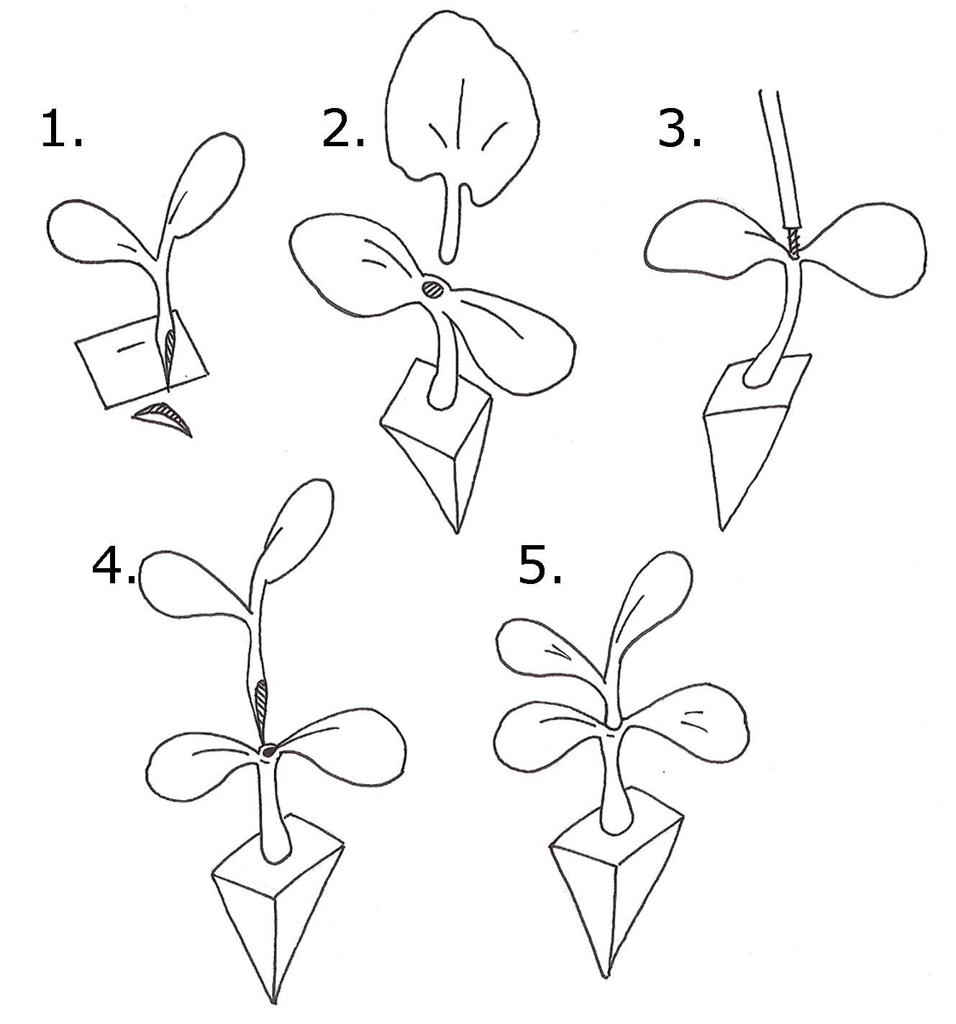

Stem grafting
The stem graft is a modified whole insertion graft. The hole is made by using a sharp blade to cut a small slit through the rootstock stem instead of the top of the meristem. Grafting seedlings are ready to be grafted once there is at least on true leaf. The watermelon is then cut at an angle below the cotyledons and inserted into the slit which can be propped open with a toothpick. Place a clamp over the union to hold up the graft. Transfer the grafted seedlings into a humidity healing chamber, and maintain temperatures at 77º F at low lighting for three days. The rootstock top should be removed after 5 days. This technique is very simple, but requires the removal of the top after the scion is healed. It also requires tight control of the humidity and temperature conditions to prevent high losses.

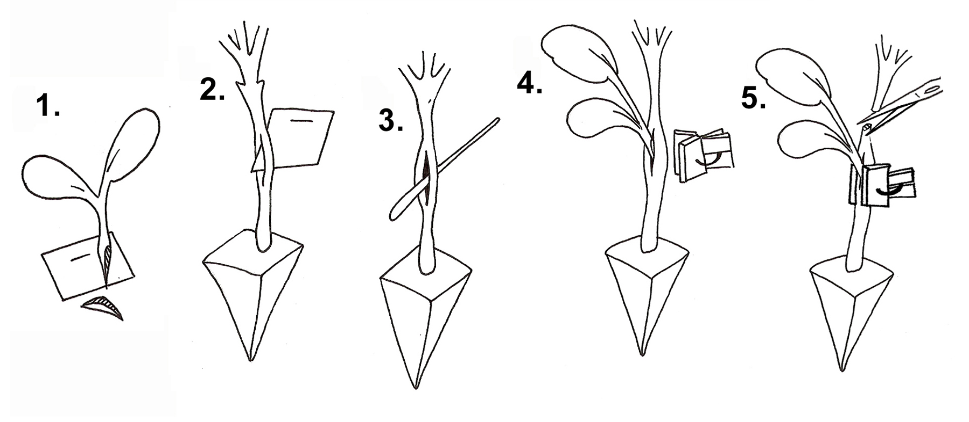

Stem Graft:
This is the graft that we have been working on that has the most promise. The Stem of the root stock is completely severed just below the cotyledons. A silicone clip is placed near the soil surface on the Stem. The stem is cut on a 35 to 45 degree angle as well as the watermelon stem material and then brought together, similar to the 0ne cotyledon graft. The clip is then slid over the grafted union and allowed to heal in the humid chamber for 7 to 10 days. Both the rootstock as well as the watermelon material has to be much older, 2 to 3 true leaves, in order for this to work. This method is still in the preliminary stages but holds a lot of promise. This method is very simple and produces no sign of meristem re-growth of the root stock material. Further research is needed for this procedure to work properly.



